Running the program
- Open Autodesk Inventor
- Select New Project
- Select Standard.ipt and then Create
- Save As on your student drive using the I-Pro -> Save-As Menu
- Create a 2d Sketch – Select the X-Y plane. It’s the one coming down to the right.

Create a rectangle
- On the 2d Sketch create a rectangle using the Rectangle command on the Sketch button bar.
- Place the first point on the origin. The origin will turn into a green circle when you are close enough to snap to it.
- Click once and then move the cursor up and to the right.
- An X coordinate box will appear. Without clicking type in 6” as a dimension and tab to the other box.
- Type 1.5” in the Y-coordinate box and hit enter. The rectangle should appear, but will be bigger than you can see on the screen.
- Use the scroll wheel to zoom out and in until the rectangle is on your screen. If it gets lost, click the magnifying class in the zoom panel towards the right of your screen. This will zoom so that everything you have drawn is visible.
- You should see a blue box with dimensions. Click on 6” and make it 16”.

Draw a second rectangle inside the first.
- Select the rectangle tool if it is not already selected
- Click to define two corners anywhere inside the first rectangle. We will dimension these next.
- Select the dimension tool (it’s near the middle of the command bar).
- Select the bottom horizontal edge of the new rectangle and move your cursor down. You will see a dimension appear. When the dimension is in a convenient spot, click again. Enter 5” in the dialog box that appears and click the green arrow. The rectangle will change sizes.
- Select the same horizontal edge and then the closest edge of the first rectangle. The dimension will change to vertical. Set this dimension to 0.5”.
- Do the same for the left vertical edges and top horizontal edges. Now all of the lines should be blue. This means that everything is fully specified.

Draw a circle.
- Draw a circle near the middle of the larger rectangle. When you are close you may see guide-lines helping you find the exact center. Click once to fix the center.
- Type 0.125” for a diameter.
- Select the dimension tool and click on the center of the circle and the bottom of the rectangle. This dimension should be 0.75”
- Create a horizontal dimension specifying 8” from the left edge of your part. The circle should now been blue.

Finish the 2d sketch and save your work.
- Click Finish Sketch on the far right of the tool bar.
- Select Save from the I-Pro menu (Top Left Corner) and give your file a name. Make sure you are saving to your named student drive.
- Zoom out so you can see your entire part.
- Click and drag the cube in the top right corner of the drawing pane and see how you can rotate the part to see different views.

Give your part some thickness using the Extrude tool.
- Select the extrude tool in the 3D Model Create tool bar.
- A dialog box should appear. If it is minimized, click the arrow so you can see the whole window
- With the Profile button highlighted, select your part. The entire part except the inner rectangle and hole should be gray when you click it.
- Set a thickness of 0.75”. Note that you can make the extrusion go towards you, away from you or both directions. For this exercise make it go away from you.

Make a counter-sink from both sides of the round hole.
- Rotate the part and zoom in so that you can see one face of the round hole.
- Click on the part near the hole. You will see three icons appear. The right one will let you create a new sketch – click it.
- Your original lines will appear in yellow. These will be handy for referencing your new features.
- Draw a ½” circle that share a center with the small one by clicking the square in the center and then entering 0.5” for a diameter.
- Finish the Sketch and return to the 3d part.
- Select extrude, and move until the doughnut around your hole highlights.
- Set an extrusion distance of 0.125” INTO the part.
- Repeat the entire process for the other side. You will need to change your view so you can see what you are doing.
- Save your work.
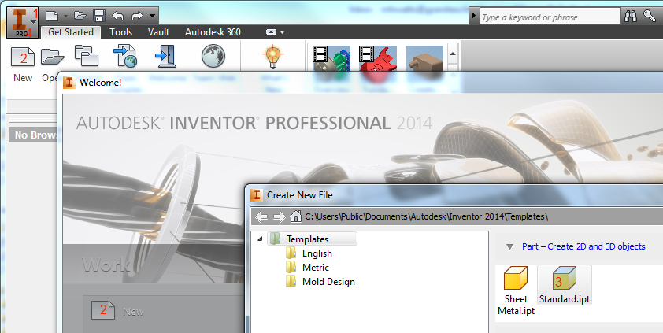
Standard ipt
New File
New File
Start inventor and create a new file. Save the file on YOUR STUDENT DRIVE.
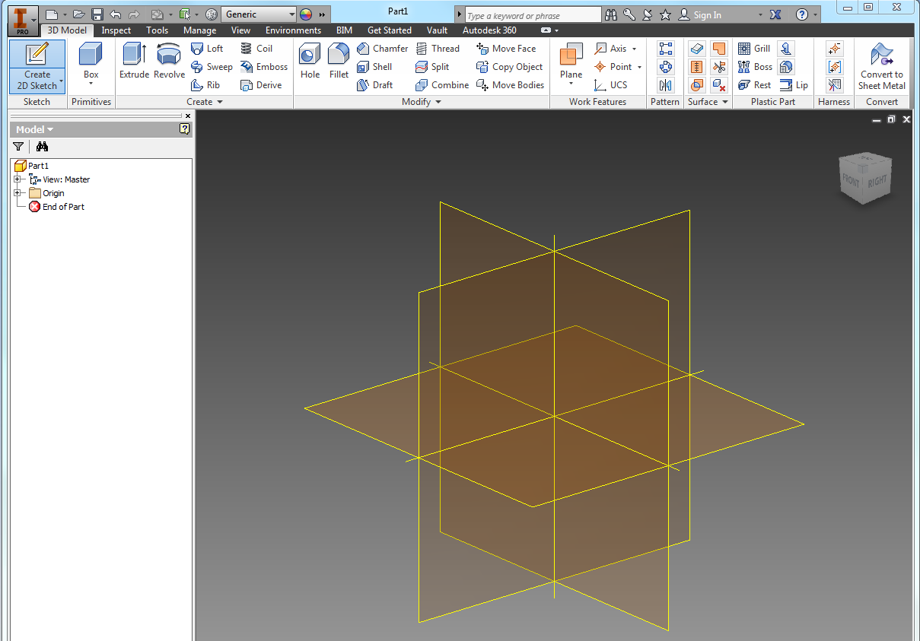
XY
Create a new 2D Sketch on the X-Y plane.
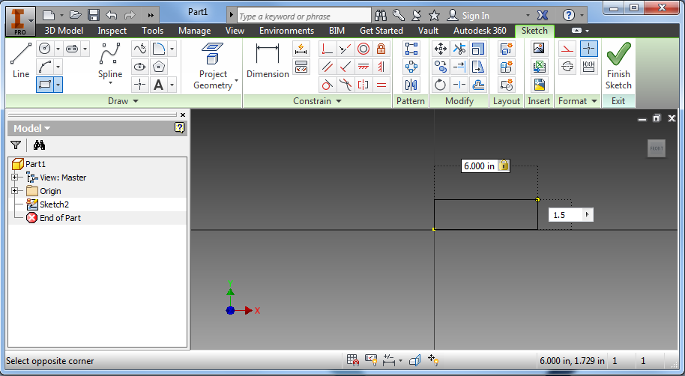
Origin
Create a 2-point rectangle starting at the origin. Type dimensions as shown.
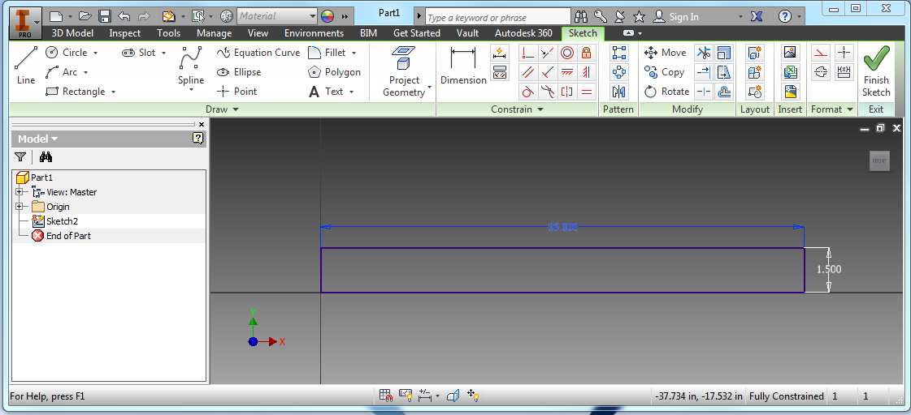
Change the upper dimension 16” and zoom out until you can see the whole rectangle.
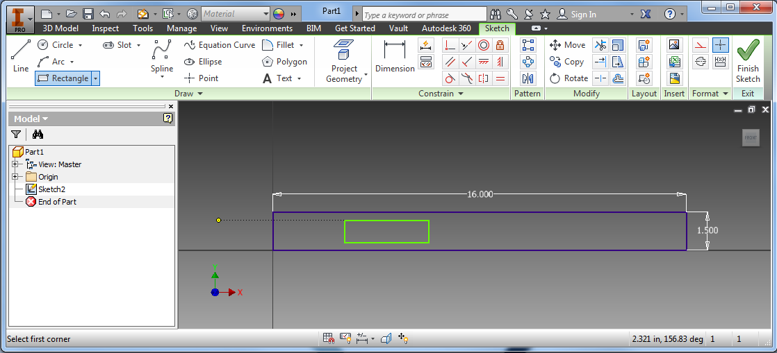
Create a second rectangle inside the first.
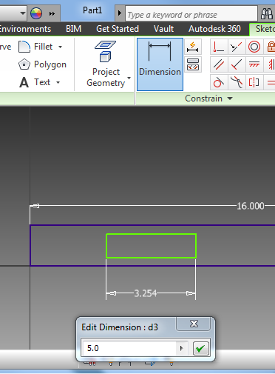 | 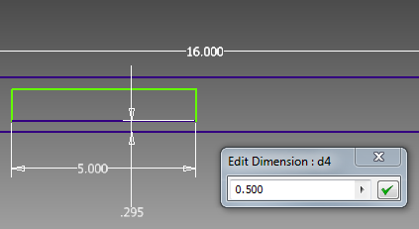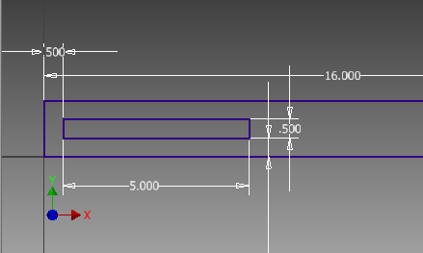
Create a box inside the first and then dimension it using the Dimension command.
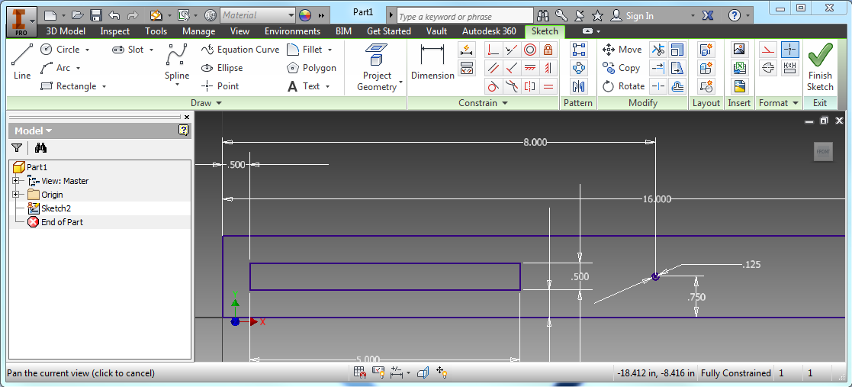
Draw a Circle in the middle of the part. Its diameter should be 0.125. Use the Dimension tool to fix it 0.75” vertically and 8.00” horizontally. Finish and save your sketch.
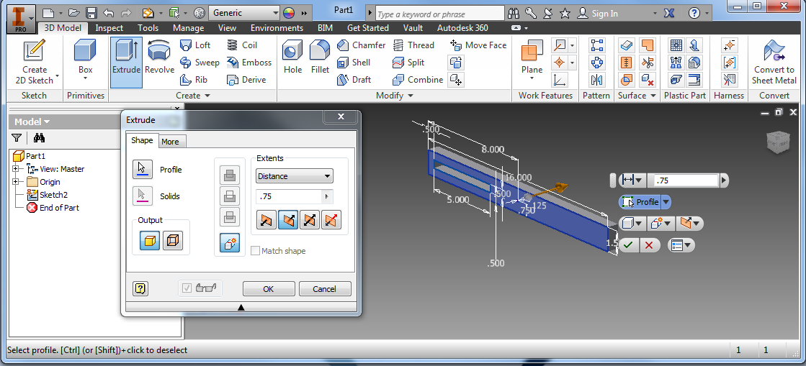
Give the part thickness by extruding it away from you.
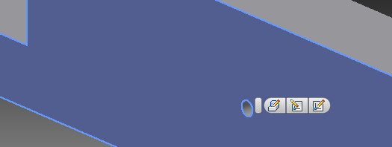
Right-click near the hole and select the Create Sketch icon.
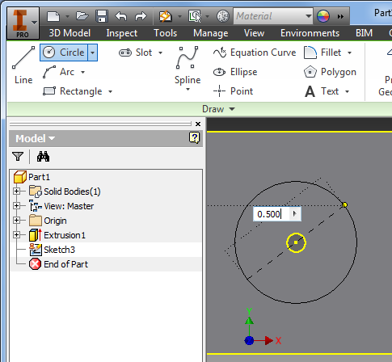
Draw a ½” circle that shares a center with the small one. Finish the sketch and return to the 3d part.
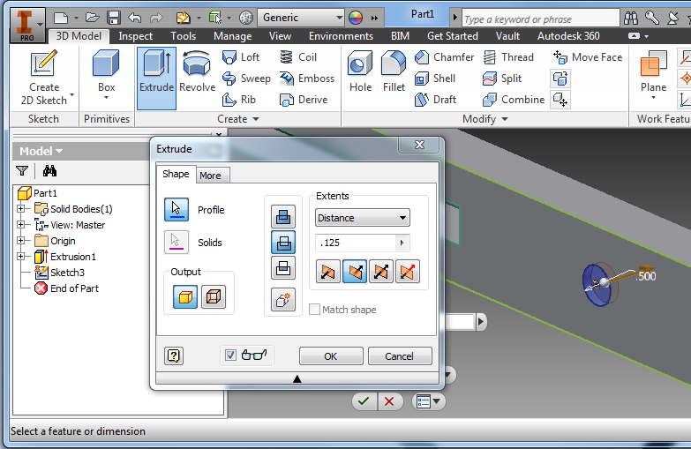
Select extrude, and move until the doughnut around your hole highlights. Set an extrusion distance of 0.125” INTO the part.
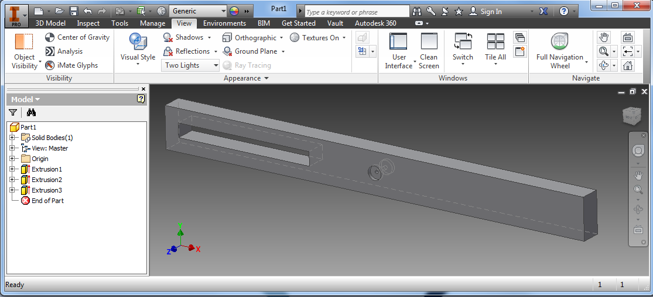
Repeat the entire process for the other side. You will need to change your view so you can see what you are doing. Save and submit your work!

